HEALTH BUDDY

A PROJECT REPORT

Submitted by,

TULSI RAM REDDY.K - 20211CSE0086
CHALLA PAVAN TEJA -20211CSE0105
MANDADI VIGNESH -20211CSE0085
SANNEBOINA ANJANEYULU -20211CSE0765

Under the guidance of,
Mr. AMARNATH J L
Assistant Professor
School of Computer Science and Engineering,
Presidency University, Bengaluru

in partial fulfillment for the award of the degree of
BACHELOR OF TECHNOLOGY

IN

COMPUTER SCIENCE AND ENGINEERING

At



PRESIDENCY UNIVERSITY
BENGALURU
DECEMBER 2024

PRESIDENCY UNIVERSITY

SCHOOL OF COMPUTER SCIENCE ENGINEERING

CERTIFICATE

This is to certify that the Project report “HEALTH BUDDY” being submitted by “TULSI RAM REDDY.K” bearing roll number(s) “20211CSE0086”,by “CHALLA PAVAN TEJA” bearing roll number(s) “20211CSE0105”, by “MANDADI VIGNESH” bearing roll number(s) “20211CSE0085”, by “SANNEBOINA ANJANEYULU” bearing roll number(s) “20211CSE0765”in partial fulfillment of the requirement for the award of the degree of Bachelor of Technology in Computer Science and Engineering is a bonafide work carried out under my supervision.
Mr. AMARNATH JL  Assistant Professor  School of CSE  Presidency University | Dr. Asif Mohammed  HoD  School of CSE&IS  Presidency University

Dr. L. SHAKKEERA  Associate Dean  School of CSE  Presidency University | Dr. MYDHILI NAIR  Associate Dean  School of CSE  Presidency University | Dr. SAMEERUDDIN KHAN  Pro-Vc School of Engineering  Dean -School of CSE&IS  Presidency University

PRESIDENCY UNIVERSITY

SCHOOL OF COMPUTER SCIENCE ENGINEERING

DECLARATION

We hereby declare that the work, which is being presented in the project report entitled HEALTH BUDDY in partial fulfillment for the award of Degree of Bachelor of Technology in Computer Science and Engineering, is a record of our own investigations carried under the guidance of Mr. AMARNATH JL, Assistant Professor, School of Computer Science Engineering & Information Science, Presidency University, Bengaluru.

We have not submitted the matter presented in this report anywhere for the award of any other Degree.

Names Roll No’s Signatures
TULSI RAM REDDY.K - 20211CSE0086
CHALLA PAVAN TEJA - 20211CSE0105
MANDADI VIGNESH - 20211CSE0085
S.ANJANEYULU - 20211CSE0765

ABSTRACT
The Health Buddy app is an innovative solution designed to address critical challenges in personal healthcare management, ensuring timely and informed access to health insights for better decision-making. The app simplifies the complexities of tracking and maintaining health by providing users with real-time, personalized information on diet, exercise, and health metrics. By predicting potential deficiencies, lifestyle-related health risks, and diseases, it empowers individuals to make proactive, data-driven choices to improve their overall well-being. This approach enhances individual health outcomes while promoting preventive care to reduce long-term health risks.
At the core of Health Buddy is its robust and scalable backend architecture, leveraging advanced technologies for dynamic data processing and secure data management. The app also includes a user-friendly interface, timely notifications, and secure data storage to prioritize user convenience and privacy.
In essence, Health Buddy acts as a comprehensive health management companion, bridging the gap between users and the information they need to lead healthier lives. It is not just a health-tracking app but a holistic system that improves decision-making, encourages preventive care, and adapts to the evolving needs of its users. Health Buddy ensures that individuals receive the support they need to maintain optimal health. Its potential for future enhancements positions it as a scalable, long-term solution in the rapidly changing healthcare landscape.
The Health Buddy app represents a groundbreaking advancement in personal healthcare management by combining lab testing, buying medicine, and actionable health insights into a single, user-friendly platform. Designed to address the growing demand for personalized and preventive healthcare solutions.By leveraging advanced technologies, Health Buddy provides predictive insights into potential nutrient deficiencies, chronic diseases, and lifestyle-related risks, offering timely recommendations to mitigate these issues.
The app’s ability to deliver instant, data-driven suggestions makes it a proactive tool for users looking to improve their overall well-being. It integrates seamlessly with wearable devices, enabling continuous and precise monitoring of physical activity, heart rate, and other key parameters. This integration ensures that users have access to real-time feedback, fostering a consistent and holistic approach to health management. In addition, the app’s real-time updating mechanism ensures the accuracy of insights, helping users adapt their lifestyle decisions promptly based on changing health trends.
In conclusion, the Health Buddy project embodies a transformative approach to health and wellness, emphasizing the power of partnership and mutual support. By combining motivation, accountability, emotional reinforcement, and resource sharing, the Health Buddy framework creates a dynamic and holistic pathway to achieving health goals. It redefines the wellness journey, turning it into a shared adventure that is not only more effective but also more enjoyable and fulfilling. This innovative concept has the potential to revolutionize how individuals approach their health, making lasting lifestyle changes a reality for people from all walks of life. The Health Buddy initiative is not just about reaching specific health milestones; it is about building a supportive and empowering relationship that fosters growth, resilience, and a lifelong commitment to well-being.
Moreover, the adaptability of the Health Buddy framework makes it suitable for a wide variety of health and wellness goals. Whether the focus is on managing chronic conditions, improving fitness, adopting a healthier diet, or even enhancing mental health, a Health Buddy can tailor their support to meet the specific needs of their partner. This flexibility is one of the concept’s greatest strengths, as it allows the partnership to evolve over time. For example, one individual might initially need encouragement to begin exercising but later shift their focus to refining dietary habits or managing stress. The Health Buddy adapts alongside these changing goals, providing consistent and personalized support at every stage of the journey.
Looking ahead, Health Buddy is designed with adaptability in mind. Future enhancements may include expanded compatibility with emerging wearable technologies, integration with telemedicine platforms, and advanced AI-driven features such as voice assistants for hands-free health management. These enhancements position the app as a transformative solution in the ever-evolving healthcare landscape, capable of addressing new challenges and meeting diverse user needs.
Finally, the Health Buddy initiative has the potential to extend beyond individual partnerships and integrate into larger wellness programs and communities. Corporations, schools, and healthcare providers could implement Health Buddy systems to improve outcomes in employee wellness, student health, and patient care. For example, workplaces could pair employees with similar health goals to encourage active participation in wellness initiatives, while schools could use the system to promote healthy habits among students. The scalability and adaptability of the Health Buddy framework make it a versatile tool for fostering healthier societies. By prioritizing collaboration, emotional support, and shared success, the Health Buddy model has the capacity to inspire profound changes at both individual.

ACKNOWLEDGEMENT

First of all, we indebted to the GOD ALMIGHTY for giving me an opportunity to excel in our efforts to complete this project on time.
We express our sincere thanks to our respected dean Dr. Md. Sameeruddin Khan, Pro-VC, School of Engineering and Dean, School of Computer Science Engineering & Information Science, Presidency University for getting us permission to undergo the project.
We express our heartfelt gratitude to our beloved Associate Deans Dr. Shakkeera L and Dr. Mydhili Nair, School of Computer Science Engineering & Information Science, Presidency University, and Dr .Asif Mohammed Head of the Department, School of Computer Science Engineering & Information Science, Presidency University, for rendering timely help in completing this project successfully.
We are greatly indebted to our guide Mr.Amarnath JL Assistant Professor
and Reviewer Ms. Akkamahadevi, Assistant Professor, School of Computer Science Engineering & Information Science, Presidency University for his inspirational guidance, and valuable suggestions and for providing us a chance to express our technical capabilities in every respect for the completion of the project work.
We would like to convey our gratitude and heartfelt thanks to the PIP2001 Capstone Project Coordinators Dr. Sampath A K, Dr. Abdul Khadar A and Mr. Md Zia Ur Rahman, department Project Coordinators Mr. Amarnath J L and Git hub coordinator Mr. Muthuraj.
We thank our family and friends for the strong support and inspiration they have provided us in bringing out this project.

Tulsi RamReddy.K
Challa Pavan Teja
Mandadi Vignesh
SanneboinaAnjaneyulu

LIST OF TABLES

Sl. No. | Table Name | Table Caption | Page No.
1 | Table 1.1 | Software modules versus Reusable components | 5

LIST OF FIGURES

Sl. No. | Figure Name | Caption | Page No.
1  2  3  4  5  6  7  8  9  10  11  12  13 | Figure 4.2  Figure 6.1  Figure 1  Figure 2  Figure 3  Figure 4  Figure 5  Figure 6  Figure 7  Figure 8  Figure 9  Figure 10  Figure 11 | Design template  Detailed explanation steps  login Page  Home Page  Registration Page  Lab Test Page  Lab Test Cart Items Page  Buy medicines Page  Buy medicine Details Page  Medicines Cart Page  Health Article Page  Health Article Details Page  Order Details Page | 30  34  49  50  51  52  53  54  55  56  57  58  59

TABLE OF CONTENTS

CHAPTER NO. | TITLE | PAGE NO.
1  2  3  4  5  6  7  8  9  10  11  12 | ABSTRACT  ACKNOWLEDGEMENT  LIST OF TABLES  LIST OF FIGURES  INTRODUCTION  - Overview  1.1 Overview of health buddy  - Concept and Origin of Health Buddy  - Importance of Social Support in Health Goals  - Differences Between Health Buddy and Traditional Approaches  - Motivation and Encouragement  1.2 Features of the Health Buddy Framework  1.2.1 Health Articles and Resources  1.2.2 Medicine Purchasing  1.2.3 Lab Testing  1.3 Benefits of the Health Buddy System  1.3.1 Enhanced Motivation  1.3.2 Improved Results  1.3.3 Resource Sharing  1.4 Key Features of the Health Buddy System  1.4.1 Accountability  1.4.2 Emotional Support  1.5 Future Implication of the Health Buddy  1.5.1 Potential for widespread adoption  1.5.2 Integration with digital health tools  LITERATURE SURVEY  2.1 Related Work  RESEARCH GAPS OF EXISTING METHODS  3.1 System Analysis  3.1.1 Existing System  3.1.2 Proposed System  3.1.3 Project flow  PROPOSED MOTHODOLOGY  4.1 User Research and Analysis  4.2 Design & Development  4.3 Testing & feedback  4.4 Launch & monitor  4.5 Data security and privacy  4.6 User Cantered Iterations  4.7 Long-Term engagement & support  OBJECTIVES  5.1 User friendly interface  5.2 Data Privacy & Security  5.3 Providing educational resources  5.4 Sustainability & long-term health  SYSTEM DESIGN & IMPLEMENTATION  6.1 Detailed explanation of steps  6.1.1 Database setup  6.1.2 User Management  6.1.3 Home page with features  6.1.4 Order Management  6.1.5 Integration of Functionalities  6.1.6 Logout & Security  TIMELINE FOR EXECUTION OF  PROJECT  OUTCOMES  8.1 Realtime data Access  8.2 User friendly Experience  8.3 Enhanced Health & Resource Optimization  8.4 Integration with emergency health features  RESULTS AND DISCUSSIONS  9.1 Results  9.1.1 Improved Access to Healthcare services  9.1.2 Optimized Resource Utilization  9.1.3 Faster Emergency Response  9.1.4 Data-Driven Decision Making  9.1.5 Increased Trust & Transparency  9.2 Discussions  9.2.1 Impact on healthcare Accessibility  9.2.2 User Experience & Engagement  9.2.3 Integration with emergency services  9.2.4 Data Privacy & Security  9.2.5 Scalability & Future Enhancements  9.2.6 Cost-Effectiveness & Affordability  CONCLUSION  REFERENCES  Pseudo Code | 4 – 5  6  7  8  12 - 19  20 - 25  26 - 28  29 - 31  30 - 33  34 - 37  38  39 - 41  42 - 45  46  47  48

CHAPTER-1
INTRODUCTION

1.OVERVIEW
The Health Buddy application is an innovative platform developed to streamline access to healthcare services during emergencies, providing a reliable and efficient solution for patients and their families. The app is designed to address common challenges in healthcare, such as delays in identifying appropriate facilities, overcrowding in hospitals, and lack of information about available resources. By offering real-time data on hospital bed availability, specialist doctors, emergency care facilities, and user reviews, the application enables users to make informed decisions swiftly, especially during critical situations when time is a determining factor in saving lives. This user-centric approach ensures that individuals can locate and access medical care tailored to their specific needs, eliminating uncertainty and reducing delays that can often prove detrimental in emergencies.

The backend architecture of the Health Buddy app is built on robust technologies, utilizing Java for efficient data processing and MySQL for secure data storage and retrieval. This infrastructure ensures that the app can handle a vast database of hospitals and healthcare providers while delivering real-time updates on the availability of services. The seamless integration of data processing and storage ensures that users are presented with accurate and up-to-date information, even in high-traffic scenarios, such as during natural disasters or widespread medical emergencies. The app’s design emphasizes reliability, enabling it to cater to a diverse user base and remain functional under demanding conditions.

One of the standout features of the Health Buddy app is its intuitive and user-friendly interface, which has been meticulously crafted to provide a seamless experience for users of all ages and technical expertise. The app simplifies the process of finding healthcare facilities by offering advanced filtering options, allowing users to search based on specific criteria such as required treatments, specialties, and availability of critical care units. This dynamic filtering not only saves valuable time but also ensures that patients are directed to the most appropriate facilities for their unique medical needs. The app’s clean and straightforward layout ensures that even in high-pressure situations, users can access the necessary information without confusion or delays, making it an indispensable tool during emergencies.

Shared goals are another critical aspect of this partnership. When two people work toward similar objectives, they create a sense of camaraderie that fuels mutual success. Whether it's reaching a specific weight target, adopting healthier eating habits, or following an exercise routine, having aligned goals ensures both partners stay focused and consistent in their efforts, enhancing the likelihood of achieving desired outcomes.

In addition to motivation and accountability, a Health Buddy also offers vital emotional support throughout the journey. Wellness goals are not just physical, they also involve mental and emotional well-being. By sharing struggles, celebrating wins, and providing a listening ear, Health Buddies create a balanced support system that makes the wellness journey less isolating and more enjoyable.

The partnership also promotes resource sharing, where both individuals exchange knowledge, tips, and tools that can enrich their health journey. From discovering new healthy recipes to trying innovative workout routines, this collaboration broadens the range of strategies available for achieving wellness, helping each person learn and grow together.

The benefits of having a Health Buddy extend beyond just motivation and accountability. One of the most significant advantages is the enhancement of health outcomes. Studies have shown that people who receive social support during their wellness journey tend to achieve better results than those who go it alone. Whether it’s weight loss, improved fitness, or managing chronic conditions, the presence of a Health Buddy can drive greater consistency and commitment, leading to more effective and sustainable progress.

Furthermore, a Health Buddy can make the entire process of pursuing health goals more enjoyable. Increased enjoyment in activities such as exercising or cooking healthy meals can make these routines feel less like chores and more like fun, shared experiences. By turning solitary tasks into social interactions, Health Buddies introduce an element of joy into the process, making it easier to stick with long-term lifestyle changes. This partnership not only improves health but also strengthens social connections, making the journey toward wellness a truly rewarding experience.

In today's fast-paced world, maintaining a healthy lifestyle can be a challenging and demanding task. With the pressures of work, social obligations, and other commitments, many individuals struggle to stay on track with their health and wellness goals. This is where the concept of a Health Buddy comes into play. A Health Buddy is more than just a friend or workout partner; it's a collaborative and supportive relationship designed to help individuals achieve their health objectives, such as improving fitness, losing weight, managing stress, and overall well-being. The Health Buddy system provides a unique opportunity for individuals to combine efforts, share knowledge, and support each other through the challenges and milestones of their health journeys.

A Health Buddy system operates on the principles of mutual support, accountability, and encouragement. It’s based on the understanding that health goals, especially long-term ones, are often more achievable when approached together. The presence of a supportive partner brings motivation, accountability, and encouragement to the table, which are essential ingredients for success in any health-related endeavor. Whether it's achieving a fitness goal, sticking to a nutritious diet, or maintaining a regular sleep schedule, the Health Buddy system offers a structured yet flexible approach that adapts to each partner's needs.

In summary, the Health Buddy system offers a holistic, collaborative, and engaging way to approach health and wellness. With a Health Buddy by their side, individuals can benefit from motivation, encouragement, accountability, and emotional support, all of which contribute to a more successful, fulfilling, and sustainable health journey.

1.1 Overview of Health Buddy

1.1.1 Concept and Origin of Health Buddy

The concept of a Health Buddy stems from the understanding that health is not just about individual physical fitness but is also influenced by emotional and social factors. Traditional approaches to health and wellness have often emphasized solitary effort, with individuals encouraged to follow a strict exercise routine or diet without much external support. However, research in psychology and health behavior suggests that social support plays a critical role in achieving health goals.

The origins of the Health Buddy concept can be traced back to behavioral science, where the power of social support was first recognized. Studies have shown that people are more likely to succeed in their health efforts when they have a support network that provides emotional encouragement and practical assistance. The idea of pairing individuals with a partner who shares similar health goals taps into this insight, ensuring that both participants are motivated and accountable to each other.

The Health Buddy model also recognizes that health goals are not always achieved quickly or easily. It is often a long-term commitment that requires persistence and emotional resilience. By providing individuals with a dedicated partner, the Health Buddy framework ensures that they have someone to rely on during difficult times, increasing their chances of sustained success. This partnership dynamic helps bridge the gap between isolated efforts and successful health outcomes.

1.1.2 Importance of Social Support in Health Goals

Social support is one of the most significant factors influencing the success of health goals. Individuals who have a reliable support system are more likely to stay motivated, committed, and focused on their objectives. This is especially true for health-related goals, which often involve long-term behavior changes such as losing weight, maintaining a balanced diet, or committing to a regular exercise routine. Health goals can be emotionally taxing, and without external support, individuals may become discouraged or give up entirely.

The Health Buddy system addresses this issue by providing continuous support from a dedicated partner who shares similar health goals. Whether it’s providing emotional encouragement during difficult times, offering practical advice on meal plans, or motivating each other to stick to exercise routines, the role of the Health Buddy is pivotal. The emotional and psychological benefits of having a buddy cannot be overstated; studies have found that people are more likely to persevere through challenges when they know they are not alone.

Additionally, social support can reduce the feelings of isolation that often accompany health challenges. Whether dealing with chronic conditions or embarking on major lifestyle changes, having someone who understands and shares in the experience can significantly alleviate stress and anxiety. A Health Buddy not only helps with motivation but also fosters a sense of community and connection, which can improve mental well-being.

1.1.3 Differences Between Health Buddy and Traditional Approaches

Traditional approaches to health often focus on individual responsibility. People are encouraged to adopt healthy habits such as exercising regularly or eating nutritious foods, but these approaches tend to overlook the importance of social support in the process. Individuals following traditional wellness plans may face challenges such as lack of motivation, accountability, or emotional support, which can hinder their progress. In many cases, the absence of a supportive partner leads to feelings of isolation and burnout, making it difficult for individuals to stay committed to their goals.

In contrast, the Health Buddy framework introduces a partnership-based approach, where two individuals work together towards shared health goals. This collaborative effort not only provides external motivation but also creates a sense of shared responsibility and accountability. Having a Health Buddy makes the journey toward health more engaging, as both individuals encourage each other, celebrate milestones, and help each other stay on track when challenges arise. The key difference lies in the emotional and social support that a Health Buddy provides, which is absent in traditional methods.

Moreover, the Health Buddy system offers personalized guidance. In traditional wellness programs, the focus is often on general recommendations that may not be suitable for everyone. However, with a Health Buddy, partners can customize their approach to meet each other's specific needs, ensuring a more tailored and effective solution to achieving health goals.
1.1.4 Motivation and Encouragement

Motivation is one of the key drivers of success in any health-related endeavor. Whether it’s overcoming the initial hurdle of starting a fitness routine or persevering during moments of doubt, the motivation to continue pushing toward health goals can sometimes be difficult to sustain. This is where the role of a Health Buddy becomes crucial. By partnering with health buddy provided health articles, an individual can find renewed motivation and encouragement that might be lacking when pursuing goals alone.

The presence of a Health Buddy provides an external source of motivation. When someone is there to cheer you on, offer words of encouragement, and celebrate your successes, it can make the journey more enjoyable. This positivity helps counter feelings of discouragement, which can often arise when progress is slow.

1.2 Features of the Health Buddy Framework

1.2.1 Health Articles and Resources

The Health Articles and Resources section of the Health Buddy App serves as a comprehensive knowledge hub, offering users curated content on a variety of health topics such as nutrition, fitness, mental health, chronic disease management, and preventive care. These articles are categorized for easy navigation and personalized based on user interests or health data, ensuring relevance and engagement. Users can explore expert-authored content, interactive features like quizzes and infographics, and even access audio versions or multilingual support for inclusivity. The section includes bookmarking for offline reading, sharing options, and daily health tips to keep users informed and motivated. With a focus on credible, expert-verified content, this feature not only empowers users with actionable insights but also integrates seamlessly with the app's tracking and prediction tools, driving proactive health management.

1.2.2 Medicine Purchasing

The Medicine Purchasing feature of the Health Buddy App simplifies access to essential medications by integrating an easy-to-use e-commerce platform. Users can browse and order medicines from verified pharmacies, ensuring quality and safety. With options to upload prescriptions, the process becomes seamless and user-friendly, catering to those with specific medical requirements. The app also provides refill reminders, helping users maintain their medication schedules without interruptions. Exclusive discounts and offers enhance affordability, while a detailed purchase history allows for easy reordering. This feature prioritizes convenience and reliability, making it an indispensable tool for proactive health management.

1.2.3 Lab Testing

The Lab Testing feature of the Health Buddy App brings diagnostic services to users’ fingertips, offering unparalleled convenience and reliability. Users can book a wide range of lab tests with trusted diagnostic partners, with the option for at-home sample collection to save time and effort. Test results are delivered directly within the app, allowing users to track and manage their health efficiently. Personalized test suggestions, based on health data trends and user history, ensure proactive health monitoring. The feature also provides reminders for periodic tests and maintains a secure record of all test reports for easy access. By combining convenience, accuracy, and personalization, the Lab Testing feature empowers users to stay on top of their health.

1.3 Benefits of the Health Buddy System

1.3.1 Enhanced Motivation

The primary benefit of the Health Buddy framework is the enhanced motivation it provides. Motivation is essential for achieving health goals, yet it is often difficult to maintain, especially when progress seems slow or setbacks occur. Having a Health Buddy makes it easier to stay motivated because the partnership provides a consistent source of support and encouragement. This support helps individuals stay focused on their goals, even when faced with challenges or temptations. Furthermore, the shared nature of the partnership ensures that both individuals are equally invested in each other's success, which creates a strong sense of accountability.

In addition to emotional support, the Health Buddy framework introduces external motivation. Knowing that someone else is counting on you to meet your goals can be a powerful driver of commitment. This sense of accountability increases follow-through, ensuring that individuals do not give up prematurely. Moreover, the regular communication and check-ins between partners help reinforce the importance of their shared goals, leading to greater motivation and sustained effort.

1.3.2 Improved Results

Research shows that social support can significantly improve health outcomes. The presence of a supportive partner can make the difference between success and failure in achieving health goals. Studies have found that individuals who have social support systems are more likely to experience better results in areas such as weight loss, physical fitness, and mental well-being. The Health Buddy system leverages this evidence by pairing individuals with a dedicated partner who helps them stay accountable, motivated, and focused on their goals. This partnership boosts the likelihood of success, as individuals are more likely to stick to their routines and strategies when they have someone to share the journey with.
Moreover, the collaborative nature of the Health Buddy system ensures that both partners learn from each other's experiences, which can lead to improved results. By exchanging tips, strategies, and insights, the partners can find more effective ways to reach their health goals. This collaborative learning helps individuals refine their routines and adopt new approaches that might be more effective.
1.3.3 Resource Sharing

Resource sharing is another vital feature of the Health Buddy system. A Health Buddy relationship is not just about motivation and accountability; it’s about providing both partners with the resources they need to succeed. These resources can include a wide variety of tools and strategies, such as workout plans, nutrition guides, health apps, and wellness blogs. By sharing their knowledge and experiences, Health Buddies can help each other discover new techniques or approaches that they may not have encountered on their own.

For instance, one Health Buddy might share a new workout routine that has proven effective for them, while the other might offer insights on healthy recipes or meal-prepping tips. This exchange of information enriches the experience for both partners, as they gain access to a broader range of resources and tools. Moreover, sharing resources ensures that neither individual feels isolated or unsupported in their journey.

Beyond physical resources, Health Buddies can also share motivational content such as inspiring quotes, articles, or podcasts that keep each other focused and positive. This constant exchange of knowledge and support creates a dynamic learning environment in which both partners can continuously grow and refine their approach to health and wellness.

1.4 Key Features of the Health Buddy System

1.4.1 Accountability

One of the fundamental features of the Health Buddy system is the emphasis on accountability. Accountability is essential in any health or wellness journey, as it helps individuals remain committed to their goals and ensures they stay on track. Often, individuals struggle with consistency when they are left to their own devices, especially when there is no one to check in on their progress or hold them accountable. The Health Buddy system addresses this challenge by pairing individuals with a partner who is directly involved in their health journey. This built-in accountability ensures that both partners are continually reminded of their goals and their progress.

The concept of mutual accountability is central to the success of the Health Buddy system. It is not just about one person holding the other accountable; both individuals are equally responsible for maintaining their commitments to each other. This reciprocal responsibility strengthens the partnership, ensuring that neither partner feels like they are doing all the work. The constant exchange of encouragement and progress updates fosters a sense of accountability, which significantly increases the chances of success.

1.4.2 Emotional Support

Health and wellness journeys are often marked by emotional highs and lows, which can have a significant impact on an individual’s motivation and persistence. The Health Buddy system addresses these emotional challenges by providing a source of emotional support throughout the process. Emotional support is particularly crucial in helping individuals overcome the feelings of discouragement and frustration that are often experienced during difficult times.

The Health Buddy framework recognizes that mental and emotional health are just as important as physical health when it comes to overall wellness. The role of a Health Buddy is to offer empathy, encouragement, and reassurance when things get tough. When an individual is feeling demotivated or has experienced a setback, their Health Buddy can provide a listening ear, offer words of encouragement, and remind them of their long-term goals. This emotional support helps mitigate feelings of isolation and can make the difference between giving up and persevering toward success.

1.5 Future Implications of Health Buddy System

1.5.1 Potential for Widespread Adoption

The future of the Health Buddy system is promising, with potential for widespread adoption across various sectors of health and wellness. As individuals and organizations continue to recognize the importance of social support in achieving health goals, collaborative wellness models like the Health Buddy system are expected to grow in popularity. Digital platforms, mobile apps, and virtual wellness communities are likely to incorporate this model, making it more accessible to a broader audience.

In addition to individual wellness, the Health Buddy system has the potential to transform how health programs are delivered in workplace settings, fitness centers, and healthcare environments. By integrating social support into these programs, organizations can improve the outcomes of wellness initiatives and promote a culture of health that extends beyond the individual. As the demand for holistic wellness programs increases, the Health Buddy system is likely to become a key component in achieving sustainable health improvements.

1.5.2 Integration with Digital Health Tools

The integration of the Health Buddy system with digital health tools holds immense potential. Mobile applications, fitness trackers, and online wellness platforms could provide individuals with seamless access to their Health Buddy, offering real-time communication, progress tracking, and goal-setting features. These digital tools would enhance the effectiveness of the Health Buddy system by making it more interactive, personalized, and scalable.

Wearable devices such as fitness trackers or smartwatches can be linked with Health Buddy platforms, enabling individuals to share data about their physical activity, sleep patterns, and nutrition. This data can be used to monitor progress, identify areas for improvement, and keep both partners accountable. Furthermore, AI-driven recommendations can provide tailored advice, enhancing the overall experience. The integration of digital tools makes it easier to pair individuals with compatible partners based on shared health goals, ensuring that the Health Buddy system is more accessible, customizable, and efficient.

CHAPTER-2
LITERATURE SURVEY
  - Related Work

[1] Vasilenko et al. (2024): Social Support and Health Outcomes Vasilenko et al. (2024) explore the critical role of social support in influencing health outcomes.

The study finds that individuals who have strong, supportive networks are significantly more likely to engage in health-promoting behaviors and experience better health outcomes. Social support, which can be emotional, informational, or instrumental, has been shown to have a positive impact on behaviors such as maintaining physical activity, following a balanced diet, and adhering to medical treatments. This finding is central to the Health Buddy system, where mutual support between individuals facilitates the achievement of shared health goals.

In the context of Health Buddies, this research reinforces the idea that having a partner who provides regular encouragement and accountability is instrumental in achieving lasting health behavior change. The study also highlights that individuals who participate in health improvement programs with a support system have higher motivation levels, leading to more consistent adherence to their health plans. By having someone to share both the struggles and successes of their health journey, participants are less likely to give up on their goals, which results in better long-term outcomes.

Vasilenko et al. (2024) also stress the importance of shared social experiences in enhancing emotional well-being. When individuals engage in health-related activities with others, they benefit not only from the practical support provided but also from the emotional satisfaction that comes with social connection. This emotional bond can reduce feelings of isolation and increase confidence, which is why the Health Buddy system can be an effective model for individuals looking to improve their health and wellness.

[2] Lundgren et al. (2024): Emotional Support and Behavior Change Lundgren et al. (2024) emphasize the pivotal role of emotional support in facilitating behavior change.

Particularly in the context of weight loss and fitness programs. The authors highlight that emotional support, especially from a Health Buddy, helps individuals overcome emotional barriers that can hinder the process of health behavior change. Emotional encouragement from a partner provides a sense of security and trust, allowing individuals to persist through challenges, setbacks, and plateaus that often derail health efforts.

The study further explores the role of emotional resilience, noting that individuals with a strong support system experience reduced stress and anxiety levels, which can otherwise impair health progress. Health Buddies provide more than just practical advice—they offer a psychological buffer that helps individuals navigate the emotional ups and downs of their health journeys. This emotional support is especially important when individuals face difficult circumstances, such as injury, failure, or moments of self-doubt.

Lundgren and colleagues also suggest that emotional support fosters a positive feedback loop where individuals feel empowered to continue their health efforts. As they receive encouragement and affirmation from their Health Buddy, they become more motivated to stick to their routines. This cycle of reinforcement enhances the likelihood of sustaining health behavior change over time, making emotional support an indispensable element of the Health Buddy system.

[3] Smith et al. (2023): The Role of Accountability in Fitness Programs In their research, Smith et al. (2023) examine the influence of accountability on success in fitness programs.

The study reveals that individuals who have an accountability partner—whether a friend, trainer, or Health Buddy—are more likely to achieve their health and fitness goals. This accountability stems from the commitment to another person, which creates a sense of obligation and encourages individuals to stay consistent with their fitness routines. The presence of a Health Buddy increases the likelihood of following through with plans, as individuals feel that their actions are being observed and that they are responsible not only to themselves but to their partner as well.

The study also points out that health-related accountability has several components, including goal-setting, progress tracking, and feedback. Health Buddies help individuals set realistic, achievable goals, provide regular check-ins, and offer constructive feedback. This structured support system reinforces positive behaviors and motivates individuals to keep moving forward, even when motivation may wane. Through this framework, accountability partners are able to track progress and celebrate small victories together, which further boosts motivation and creates a sense of achievement.

Smith et al. (2023) conclude that accountability within a Health Buddy system is critical in enhancing adherence to health behaviors. The research shows that accountability partners foster a sense of responsibility, which is a driving force behind successful health behavior change. With the support of a Health Buddy, individuals can maintain their commitment to health routines and overcome obstacles that might otherwise derail their progress.

[4] Cooper et al. (2024): Motivation and Health Behavior Change Cooper et al. (2024) conduct a comprehensive study on the role of motivation in health behavior change.

According to their findings, motivation is the primary driver behind sustained health behaviors. Motivation can either be intrinsic, driven by personal enjoyment and satisfaction, or extrinsic, based on external rewards or social expectations. The researchers note that intrinsic motivation is especially powerful when it comes to long-term behavior change, but extrinsic motivators, such as encouragement from a Health Buddy, can significantly boost engagement and effort during challenging periods.
Health Buddies provide the necessary external motivation to keep individuals on track with their health goals. This external motivation comes in many forms, including praise, rewards, and positive reinforcement. According to Cooper et al. (2024), when individuals receive encouragement from their Health Buddy, they feel more compelled to continue with their efforts, even when faced with obstacles such as fatigue or discouragement. The support of a buddy provides a psychological boost that helps individuals overcome temporary setbacks and maintain their commitment to their wellness journey.

The study also emphasizes the importance of goal-setting and feedback in maintaining motivation. Health Buddies not only encourage their partners but also help set clear, realistic goals and provide feedback on progress. This structure helps individuals stay focused and motivated, as they can see tangible progress toward their health objectives. By combining intrinsic motivation with the external encouragement provided by a Health Buddy, individuals are more likely to achieve long-term success in their health and wellness endeavors.

[5] Jackson & Davy (2023): Shared Goals and Long-term Wellness Success Jackson and Davy (2023) explore the importance of shared goals in long-term wellness success.

The study demonstrates that individuals who collaborate with others on health goals are more likely to succeed than those who pursue their objectives alone. The concept of shared goals within a Health Buddy system involves both individuals setting common health-related objectives and working together to achieve them.

This shared commitment creates a sense of partnership and collective responsibility, which strengthens motivation and accountability.
The research highlights that when individuals pursue health goals as a team, they experience greater emotional satisfaction and engagement. The study also notes that mutual support in achieving goals fosters a sense of belonging and social connectedness, which positively impacts mental well-being. By sharing health goals, partners can celebrate victories together, help each other navigate setbacks, and provide ongoing encouragement. This approach leads to better adherence to health routines and enhances overall satisfaction with the health journey.

Jackson and Davy further argue that the collaborative nature of shared goals in the Health Buddy system is particularly effective in tackling complex health issues such as weight loss, fitness improvement, and mental health. When both partners share the same objectives, they are more likely to remain committed to their health routines, as they have a strong social and emotional investment in their partner's success as well as their own.

[6] Jones & Roberts (2024): Resource Sharing in Health Buddy Systems Jones and Roberts (2024) examine the role of resource sharing in health behavior change, specifically within Health Buddy partnerships.

They find that resource sharing—such as exchanging fitness tips, diet plans, workout schedules, and health-related articles—greatly enhances the success of health behavior change efforts. Health Buddies who share their knowledge, experience, and resources can provide practical advice and tools that might not otherwise be accessible. This resource sharing helps individuals overcome obstacles and discover new methods or strategies that can optimize their health outcomes.

The study also notes that resource sharing leads to a more informed and efficient approach to health. For example, one partner might introduce a new exercise regimen, while the other might share meal planning tips that complement their shared goals. The constant exchange of information creates an environment of continuous learning and improvement, helping both partners to grow in their health knowledge and capabilities.

Jones and Roberts (2024) conclude that resource sharing within Health Buddy systems enhances health literacy and self-efficacy, which are critical factors in achieving long-term health success. Through the collaborative exchange of resources, Health Buddies can provide each other with the necessary tools, advice, and encouragement to stay on track with their wellness journeys.

[7] Miller et al. (2023): Health Buddy Systems and Emotional Well-Being Miller et al. (2023) focus on the emotional well-being benefits of Health Buddy systems.

Their research underscores that emotional support is just as important as physical support when it comes to achieving health goals. Health Buddies provide not only practical advice but also emotional reassurance, empathy, and understanding during challenging times. This emotional support helps reduce feelings of isolation, depression, and anxiety, which can be significant barriers to health behavior change.

The study also emphasizes that having a Health Buddy helps individuals build resilience, both emotionally and physically. By engaging in health behaviors with a supportive partner, individuals can better handle the stress and frustration that often accompanies health goals, such as weight loss plateaus or injury recovery. Health Buddies offer encouragement and help individuals refocus when they feel discouraged or overwhelmed, which fosters emotional stability and increases the likelihood of success.

Miller et al. (2023) conclude that social connection and emotional support are integral to the Health Buddy system. By creating a safe,
supportive environment, Health Buddies enable individuals to maintain a positive mindset, which is essential for achieving long-term health success. The emotional well-being that Health Buddies provide plays a crucial role in promoting mental health and improving overall life satisfaction.

[8] Taylor et al. (2024): The Psychological Benefits of Having a Health Buddy Taylor et al. (2024) examine the psychological benefits of having a Health Buddy.

Their research finds that individuals who have a support system in place experience greater psychological resilience when faced with challenges or setbacks in their health journeys. The emotional security provided by a Health Buddy reduces stress and anxiety, both of which are known to negatively impact health behaviors.

The study also highlights that having a Health Buddy improves self-esteem and self-worth, as individuals feel more capable and confident when they have someone to share their health journey. This confidence boosts an individual's sense of accomplishment, which is essential for overcoming barriers to behavior change. Health Buddies create a sense of shared responsibility, which reduces feelings of inadequacy and promotes positive self-perception.

Furthermore, Taylor et al. (2024) show that the psychological connection between Health Buddies fosters a sense of belonging and social engagement, which contributes to greater emotional stability and improved mental health outcomes. This support system plays a key role in ensuring individuals stay motivated and focused on their health goals, even when the going gets tough.

[9] Carson et al. (2023): The Influence of Social Networks on Health Behavior Carson et al. (2023) explore how social networks influence health behaviors, particularly in the context of fitness and wellness.

The research indicates that individuals who have a strong social network, including Health Buddies, are more likely to engage in health-promoting behaviors and maintain these behaviors over the long term. Social networks provide a support system that reinforces positive health choices and increases adherence to fitness routines, diet plans, and medical regimens.

The study also emphasizes that peer influence plays a significant role in motivating individuals to engage in healthy behaviors. Health Buddies act as positive influencers, encouraging each other to make healthy choices and stay committed to their health goals. By sharing successes, challenges, and health-related information, Health Buddies create a mutually beneficial relationship that promotes well-being.

Carson et al. (2023) conclude that social support networks, particularly in the form of Health Buddy partnerships, are crucial in driving health behavior change. These networks offer emotional, practical, and motivational support that helps individuals overcome obstacles and maintain long-term commitment to their health goals.

[10] Harrison et al. (2024): The Effectiveness of Health Buddy Apps in Behavior Change Harrison et al. (2024) focus on mobile health applications that connect individuals with Health Buddies to enhance health behavior change.

The study highlights how these apps provide real-time feedback, reminders, and social interaction features that boost motivation and accountability. By using technology, Health Buddy systems can offer individuals a more personalized and convenient way to stay connected and motivated.

The research shows that mobile apps facilitate goal tracking, progress monitoring, and social engagement, which are key factors in maintaining health behaviors. Apps can offer personalized advice, create challenges, and enable users to track their daily activities. The integration of social features allows users to share progress, achievements, and challenges with their Health Buddies, fostering a supportive and interactive environment.

Harrison et al. (2024) conclude that mobile applications can play a critical role in enhancing the effectiveness of Health Buddy systems. These platforms provide a flexible and scalable solution to support behavior change, making it easier for individuals to stay motivated, track progress, and collaborate with others on their health journey.

[11] Turner et al. (2018): Health Buddy Systems in Mental Health Support Turner et al. (2018) focus on the impact of Health Buddy systems in supporting individuals with mental health conditions.

The study finds that peer support is essential for people dealing with mental health challenges, as it helps reduce feelings of loneliness, stigma, and hopelessness. Health Buddies provide a platform for individuals to share their experiences, gain insights from each other, and receive the emotional support needed to cope with mental health issues.

The research emphasizes that mental health recovery is not just about managing symptoms; it also involves emotional healing, which is greatly enhanced by having a supportive Health Buddy. Peer support is particularly effective in reducing the stigma often associated with mental health disorders, as individuals feel more comfortable discussing their struggles in a non-judgmental environment. Health Buddies provide reassurance and empathy, which helps individuals feel validated and supported in their recovery journey.

Turner et al. (2018) conclude that Health Buddy systems play a vital role in improving mental health outcomes. By providing emotional support, reducing stigma, and offering practical advice, Health Buddies create a safe space for individuals to navigate their mental health challenges.

[12] Barnes et al. (2020): The Role of Health Buddies in Chronic Disease Management Barnes et al. (2020) examine the role of Health Buddies in the management of chronic diseases such as diabetes, hypertension, and heart disease.

Their study shows that individuals with chronic health conditions who have a Health Buddy to support them in managing their condition experience better health outcomes than those who manage their condition alone. Health Buddies can provide practical assistance in monitoring symptoms, remembering medication schedules, and adhering to treatment protocols, which are crucial in chronic disease management.
The study highlights that Health Buddies offer both emotional and logistical support, which can help reduce the burden of chronic disease management. For instance, having a partner to remind individuals about their medication or exercise routine can improve adherence and reduce the risk of complications. chronic illness, as it helps individuals cope with feelings of frustration, hopelessness, or isolation.

CHAPTER-3
RESEARCH GAPS OF EXISTING METHODS
3.1 System Analysis

System analysis involves understanding and evaluating the existing systems and defining the requirements for a new system to ensure it meets the needs of the users. In the context of health applications, system analysis is crucial for identifying the current challenges and inefficiencies in existing solutions and determining how a new system, like Health Buddy, can address those issues more effectively. The analysis begins with evaluating the existing system, followed by proposing an improved system, and then outlining the system flow, requirements, and features that the new application will have to make it a valuable tool for users aiming to track and improve their health.

3.1.1 Existing System

The current landscape of health tracking applications relies heavily on standalone solutions that often lack integration with other platforms or health devices. Existing systems typically offer basic features like lab test, buying medicine, and health articles, but fail to provide a comprehensive health monitoring experience. These applications are often limited in their ability to deliver real-time, personalized feedback, or integrate with healthcare professionals for expert guidance.

Furthermore, many health applications lack advanced security features, leading to potential privacy concerns for users.

Most traditional health apps are built around centralized databases that store user data, but these systems often face challenges related to data privacy, scalability, and interoperability. Furthermore, user engagement tends to decline over time, as many of these applications do not include effective motivation strategies or social features. As a result, users may feel isolated in their health journeys, leading to lower retention and adherence rates.

Disadvantages of existing systems:

- Limited interoperability with other health devices and apps.
- Lack of personalization and real-time feedback based on individual health data.
- Privacy concerns due to inadequate security measures.
- User disengagement over time due to a lack of social features and motivation tools.
- Limited integration with healthcare professionals for professional advice and guidance.

3.1.2 Proposed System

The proposed system, Health Buddy, aims to address the limitations of existing health applications by offering a holistic health tracking solution. By focusing on user-centric design, real-time analytics, and secure data management, Health Buddy seeks to provide a more personalized, interactive, and secure health experience. The system will integrate with various wearable devices and fitness trackers to collect data, analyze it in real-time, and provide personalized recommendations tailored to the individual’s health journey.

Unlike traditional health applications, Health Buddy will focus on promoting user engagement through features such as providing knowledge through health articles,buying medicines and peer support systems.Additionally, the system will incorporate security measures such as multi-factor authentication, end-to-end encryption, and HIPAA-compliant data handling to ensure user privacy and trust.

A significant aspect of the proposed system will be its ability to connect users with healthcare professionals through a built-in telehealth platform, where users can seek professional advice, share health data securely, and receive personalized health plans.

Advantages of the Proposed System:

- Real-Time Guidance: Provides personalized health insights and real-time recommendations for improved decision-making.
- Emergency Support: Facilitates faster response with emergency service integration and critical health data sharing.
- Comprehensive Health Management: Ensures balanced focus on diet, exercise, and mental well-being for holistic health improvement.
- Ease of Use: Offers an intuitive, accessible interface suitable for users of all ages and technical expertise.

3.1.3 Project Flow

User Registration and Profile Setup
- Users sign up and create profiles by entering basic details (age, gender, weight, height) and health goals (e.g., weight loss, fitness improvement, or chronic condition management).
- Integration with wearable devices and syncing of initial health data.
Analysing the features
- Features such as lab tests booking , buying medicines and reading health articles.
- Stores the order data and displays when needed.
Lab testing feature
- The user can book any lab test based on their requirement from the app and can also see the prices for those tests being displayed.
- It provides with the price and also the details of the scheduled date and time.
Health Article feature
- These include some important information about how to maintain their health and everything.
- It provides knowledge and helps to keep track of your health by reading them.
Emergency Support and Integration
- Emergency situations you can buy medicine from the application by selecting the required medicine from the list given.
- Sometimes this is very useful and saves us a lot of time.
Notifications and Alerts
- Send timely reminders for orders placed.
- Notify users about the lab tests appointment.
System Maintenance and Future Enhancements
- Regularly update the system for scalability and the integration of advanced features, such as voice commands and expanded emergency support.
- Ensure data security and compliance with healthcare privacy regulations.
User Registration and Profile Setup
- Registration: Users need to first register before to login to the application using their personal details like email,mobile number etc.
- Login: Using the registered username and password the user can login into the application.
- Explore features: After logging in the user can use the features available.
Storing Data
- Storing the users personal information in the android studios default database.
- Also storing the user order details and displaying when required.
Medicine Booking
- Convenience and Time-Saving: Users can search, select, and order medicines directly through the app without visiting a physical pharmacy.
- This is particularly beneficial for individuals with mobility issues, chronic illnesses, or those living in remote areas.
Access to Verified Pharmacies
- The app partners with trusted pharmacies, ensuring that users receive authentic and high-quality medications.
Emergency Medicine Access
- In urgent situations, users can locate nearby pharmacies that deliver medicines quickly, adding a layer of security for critical medical needs.

CHAPTER-4
PROPOSED MOTHODOLOGY

The methodology for the Health Buddy application integrates user-centered design, agile development, and real-time data analytics to offer a comprehensive and personalized health management platform. The approach emphasizes continuous improvement, iterative testing, and integration of emerging technologies to ensure the app remains user-friendly, engaging, and responsive to users’ evolving health needs. By placing users' health at the center of its development process, Health Buddy aims to provide a tool that adapts to individual health goals.

4.1 User Research and Analysis:

User research plays a vital role in the development of Health Buddy, as it ensures the application is closely aligned with the needs, preferences, and expectations of its target users. This phase involves conducting surveys, interviews, and focus group discussions to gather insights into users’ health habits, challenges, and goals. Through this research, we identify key features that users would value, such as tracking dietary habits, setting health goals, and receiving personalized recommendations based on their specific health needs.

Understanding user demographics, including factors such as age, health conditions, and technology proficiency, enables the design team to create a more inclusive and accessible platform. By engaging with a wide range of users, we can ensure that the app remains relevant to both tech-savvy individuals and those who may not be as familiar with digital health tools. This user-centered approach is foundational to making the Health Buddy application not only functional but truly helpful for the people who rely on it to improve their health.

4.2 Design and Development:

Once the user research is complete, the design and development phase begins, following agile methodologies to ensure iterative testing and constant user feedback. During the design phase, wireframes and prototypes of the mobile and web platforms are created, based on the research data. These designs are evaluated by a sample group of users to ensure the interface is intuitive, easy to navigate, and visually appealing. With feedback from this testing, adjustments are made before development begins.

The development phase involves the actual coding of the application, using modern technologies such as Java, Android Studio, Xcode, and web technologies like HTML, CSS, and JavaScript. Agile sprints allow the team to build the app in manageable chunks, with each iteration focusing on specific features such as health tracking, goal setting, and user feedback mechanisms. Development is followed by a thorough round of testing to ensure the functionality aligns with user expectations and that the app is ready for launch.
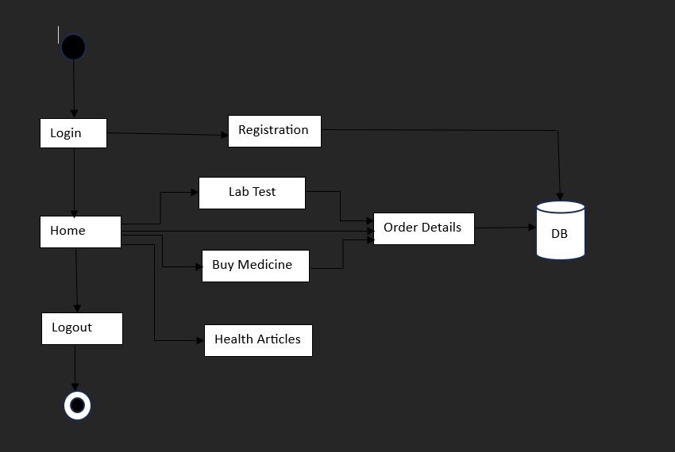

4.3 Testing and Feedback:

Once the initial version of the app is developed, the testing and feedback phase ensures that Health Buddy is fully functional and user-friendly. Testing is done across multiple platforms, including mobile devices and web browsers, to ensure compatibility and performance. Functional testing checks the core features such as user registration, goal setting, and data synchronization, while usability testing ensures the interface is intuitive and easy for users to navigate.

User feedback during this phase is invaluable in identifying bugs, usability issues, or unmet needs that may not have been apparent during development. With feedback from real users, adjustments are made to improve the app's functionality and enhance the overall user experience. This iterative testing process ensures that the final product is refined and polished, ready to meet the needs of its target audience while maintaining the highest standards of usability and performance.

4.4 Launch and Monitor:

Once Health Buddy has passed all stages of testing, it is ready for launch. The launch process involves distributing the mobile app on popular platforms such as Google Play and the Apple App Store, as well as making the web version accessible via a secure URL. During the launch, the app is actively promoted to attract initial users and gather early feedback. The goal is to create awareness about the app’s features and its ability to assist users in managing their health effectively.

Post-launch, the application is continuously monitored using analytics tools to track user behavior, feature usage, and engagement rates. This data helps the development team understand how users interact with the app, what features are most popular, and where improvements may be necessary. Real-time feedback from users is collected via in-app surveys and reviews, and this information is used to prioritize updates and introduce new features. Monitoring user engagement helps ensure the app’s long-term success by responding to changing user needs and maintaining satisfaction.

4.5 Data Security and Privacy:

Data security and privacy are essential aspects of the Health Buddy app, given that it handles sensitive personal health information. To ensure that users feel confident about sharing their health data, the app employs robust encryption methods and secure authentication protocols. All data exchanged between the user and the server is encrypted using the latest encryption technologies to prevent unauthorized access.

Additionally, Health Buddy adheres to global data protection standards, such as the General Data Protection Regulation (GDPR), which ensures that users' personal information is handled with the utmost care. The app's commitment to privacy and security builds trust with users, which is critical for maintaining engagement and promoting the app as a long-term health management tool.

4.6 User-Centered Iterations:

The Health Buddy app follows an iterative development process, with updates and new features being regularly introduced based on user feedback. As part of this process, users are encouraged to provide input on the app’s functionality and experience through in-app surveys and reviews. This continuous feedback loop allows the development team to address any pain points and introduce new features that align with users' needs.

The iterative nature of development also means that the app is always evolving, improving in response to the latest trends in health management and technology. Users can expect regular updates that enhance the app’s performance, introduce new health tracking features, and ensure that the app remains effective in helping them meet their health goals. This ongoing improvement process ensures that Health Buddy remains relevant and valuable to users over time.

4.7 Long-Term Engagement and Support:

Long-term engagement is crucial to the success of the Health Buddy application. The app aims to build a strong relationship with users by offering continuous support and resources that help them achieve their long-term health goals. To maintain engagement, Health Buddy includes features such as goal-setting tools, daily challenges, and progress tracking to encourage users to return to the app regularly and stay motivated in their health journey.

Furthermore, the app offers a dedicated support system, including access to health experts, community forums, and troubleshooting resources. This ensures that users can receive assistance whenever needed, enhancing their overall experience with the app. By fostering long-term engagement and providing consistent support.
CHAPTER-5
OBJECTIVES

The objective of the Health Buddy app is to empower individuals to take control of their health and well-being by providing personalized, accessible, and data-driven tools for managing various aspects of their physical and mental health. The app aims to serve as a reliable companion in users' wellness journeys, offering features that help monitor health metrics, set achievable goals, and adopt healthier lifestyle habits. With a focus on long-term sustainability, Health Buddy strives to provide continuous support, guidance, and motivation, ensuring users not only improve their health but also maintain those improvements over time for lasting benefits.

5.1 User friendly interface:

Accessibility and simplicity are at the core of the Health Buddy Application’s design philosophy. The app features an intuitive and user-friendly interface, ensuring that people of all ages and technical abilities can navigate it effortlessly. Key functionalities, such as accessing details about medical services, are prominently displayed, minimizing confusion during critical moments. The design includes large, easy-to-read fonts, clear labels, and icons to guide users effectively. This thoughtful design caters especially to users who may be under stress during emergencies, helping them make quick decisions without struggling to find essential features. Additionally, the app incorporates quick-action buttons for emergency situations, offering users a stress-free and efficient tool for accessing healthcare.

5.2 Data Privacy and security:

Protecting sensitive user data is a cornerstone of the Health Buddy Application. With healthcare information being particularly sensitive, the app employs robust security measures to ensure privacy and build user trust. Advanced encryption protocols safeguard data during storage and transmission, ensuring that personal and medical information remains confidential. Secure login systems, such as two-factor authentication, prevent unauthorized access to user accounts, adding an extra layer of protection. Additionally, the app complies with global data protection regulations like GDPR (General Data Protection Regulation) or HIPAA (Health Insurance Portability and Accountability Act), ensuring that all user data is handled responsibly and securely. To maintain continuous security, the app undergoes regular audits and updates to address emerging threats and vulnerabilities. Users are also given full control over their data, including the ability to manage, delete, or restrict access to their personal information. By prioritizing data privacy and security, the application fosters confidence among its users, ensuring that their trust is never compromised when interacting with the system .

5.3 Providing Educational resources:

Health Buddy offers educational content, such as articles and expert advice, to help users better understand health concepts and how to achieve lasting improvements. These resources are designed to empower users with knowledge, enabling them to take control of their health in a more informed way. Whether through tips on nutrition, stress management, or exercise, the app provides valuable tools to enhance users’ health literacy. By promoting continuous learning and growth, Health Buddy ensures that users are equipped to make lasting changes that improve their quality of life over time. Keep users informed about common health conditions and healthy habits.

5.4 Sustainability and Long-Term Health:

The objective of promoting Sustainability and Long-Term Health within a Health Buddy app is to help users develop enduring habits that foster continuous well-being, rather than focusing on temporary health improvements. By encouraging consistent, healthy lifestyle choices, the app aims to support long-term physical, mental, and emotional health. It empowers users to make gradual, sustainable changes in their diet, exercise routines, and stress management techniques, ultimately leading to a balanced and fulfilling life. The app provides ongoing guidance, monitoring, and motivation, ensuring that users can maintain their health improvements and avoid reverting to unhealthy patterns. By prioritizing long-term wellness, the app fosters lasting change that can positively impact users’ quality of life for years to come.
CHAPTER-6
SYSTEM DESIGN & IMPLEMENTATION

6.1 Detailed Explanation of the Steps:

The Proposed method consists of the following steps:

This healthcare application is designed using a three-tier architecture, consisting of a presentation layer (user interface), application layer (business logic), and data layer (centralized database). The system comprises key modules, including Login/Logout, Registration, Home, Lab Tests, Medicine Purchase, Health Articles, and Order Details.
In the high-level design (HLD), the focus is on the architecture and core functionalities, ensuring smooth navigation between features, secure data handling, and scalability. The low-level design (LLD) dives into detailed implementation for each module, such as input validation, workflows, data storage, and error handling.

6.1.1.Database Setup :
The database serves as the backbone of the Health Buddy Application, facilitating efficient management and storage of structured and dynamic data. A robust database schema is designed to organize critical information such as user details, lab test availability, medicine inventory, and order history. SQL databases like MySQL or PostgreSQL are typically used for handling structured data due to their reliability and ability to execute complex queries, while NoSQL databases such as MongoDB may be integrated for managing more dynamic or flexible data structures. Establishing a seamless connection between the database and backend involves implementing data models and leveraging ORM (Object-Relational Mapping) frameworks like Hibernate or JPA in Java, enabling smooth interaction with database tables through object-oriented programming principles. Connection pooling is configured to improve database performance by managing connections efficiently and reducing latency. Additionally, ensuring proper indexing, normalization, and query optimization enhances the speed and scalability of database operations, ensuring that large volumes of healthcare-related data can be retrieved and processed quickly.

6.1.2. User Management :
User management plays a pivotal role in maintaining the security and privacy of user information within the Health Buddy Application. It begins with a registration system that allows users to securely sign up by providing personal details like name, email, contact information, and passwords. Authentication protocols such as OAuth 2.0 and JSON Web Tokens (JWT) are implemented to validate user identity during login, ensuring secure access to the application. To protect sensitive data, passwords are hashed using algorithms like bcrypt or SHA-256 before being stored in the database. Advanced security mechanisms such as multi factor authentication (MFA) add an additional layer of protection by requiring users to verify their identity through OTPs or secondary devices. Account recovery features like password reset through secure email links are also integrated to enhance user convenience. Furthermore, role-based access control (RBAC) is implemented to differentiate user permissions based on roles—regular users can access features like order tracking, whereas administrators and healthcare providers can manage system data, orders, and appointments. This ensures users interact only with functionalities they are authorized to access.

6.1.3. Home Page with Features :
The home page of the Health Buddy Application acts as the central hub where users can access the primary features of the app in a well-organized and user-friendly layout. Designed with an intuitive interface, the dashboard displays functionalities like lab test bookings, medicine purchases, and access to health articles through clearly labeled cards or icons. Each option is visually distinct, making it easy for users to navigate the app and perform tasks efficiently. To further enhance usability, the home page incorporates personalization features that display recommendations tailored to the user’s previous activities and preferences. The design ensures responsiveness and compatibility with various devices, providing a consistent experience for users across desktops, tablets, and smartphones. By combining simplicity with functionality, the home page ensures users can quickly access essential healthcare services while maintaining a smooth and engaging interface.

6.1.4. Order Management :
The order management module in the Health Buddy Application provides a seamless way for users to handle orders related to lab tests and medicine purchases. The backend efficiently records and manages order details, including the user’s selected service, payment status, delivery timelines, and updates on the order’s progress. Each order is assigned a unique identifier to facilitate tracking and management. Users can view comprehensive order histories, including past purchases, completed tests, and pending requests, along with options to cancel pending orders or reorder previously purchased medicines. Real-time updates on delivery timelines and payment confirmations ensure transparency and keep users informed at every stage of their transactions. A user-friendly interface displays order details in an organized manner, making it easier for users to track their current and past activities. By combining order tracking, cancellation, and reordering functionalities, this module simplifies the user experience and ensures smooth management of healthcare services and transactions.

6.1.5. Integration of Functionalities :
Integrating various modules within the Health Buddy Application ensures a cohesive and seamless experience for users by linking core features to the backend system. Individual modules such as health articles, lab test booking, and medicine purchase are developed independently but are interconnected to enable smooth interactions with the database and external services. For instance, the lab test booking module manages test availability, userselected slots, and confirmation details, allowing users to schedule appointments with ease. The medicine module tracks inventory, processes orders, and coordinates delivery updates, ensuring that medicines are available and delivered on time. Backend logic ensures these modules communicate in real-time, allowing users to book, purchase, or search without disruptions. By carefully integrating these functionalities, the application provides a streamlined and efficient solution for accessing a wide range of healthcare services.

6.1.6. Logout and Security :
The logout and security mechanisms of the Health Buddy Application are designed to ensure that user sessions can be terminated securely, preventing unauthorized access, especially on shared or public devices. Logout functionality effectively clears user authentication tokens, ending the session immediately and protecting sensitive data. The application incorporates strong security measures such as SSL/TLS encryption for secure communication between users and servers, safeguarding data from interception during transmission. Secure API endpoints are implemented to restrict unauthorized access, and regular security audits are conducted to identify and address vulnerabilities. Additionally, firewalls and intrusion detection systems (IDS) are deployed to protect against cyber threats like SQL injection, cross-site scripting (XSS), and brute-force attacks. These measures collectively ensure that user data remains protected and the integrity of the system is maintained, providing a safe and reliable platform for users to access healthcare services.

CHAPTER-7
TIMELINE FOR EXECUTION OF PROJECT
(GANTT CHART)

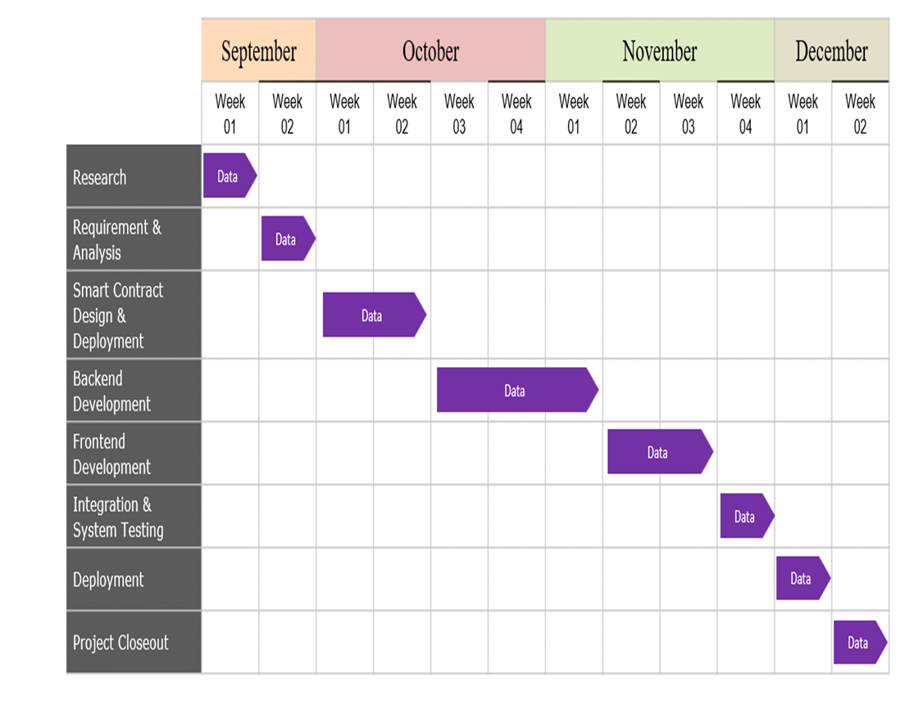

CHAPTER-8
OUTCOMES

8.1 Real-Time Data Access

The Health Buddy app is designed to provide users with real-time data access to a wide range of health-related services and information, empowering them to manage their health more effectively. It offers health articles that are continually updated, giving users access to the latest medical research, expert advice, and practical tips on managing various health conditions, promoting wellness, and preventing disease. These articles are curated from trusted sources, ensuring users receive reliable and actionable insights to improve their overall well-being. In addition, the app simplifies the process of lab testing by allowing users to book tests directly within the app, receive real-time results, and access detailed reports with personalized health recommendations. This feature helps users track their health progress and take proactive steps in managing conditions or maintaining a healthy lifestyle. Furthermore, Health Buddy offers the convenience of buying medicines through integrated partnerships with local pharmacies or online platforms, enabling users to order prescriptions, check medication availability, and receive real-time pricing and delivery options. This combination of features provides users with a comprehensive, integrated health solution, giving them the tools and resources to make informed health decisions, monitor their progress, and access necessary treatments with ease, all in one place.

8.2 User-Friendly Experience

The Health Buddy app is meticulously crafted to deliver a user-friendly experience that caters to the diverse needs of individuals looking to improve their health. From the moment users open the app, they are greeted with a simple, intuitive interface designed for easy navigation. Health articles are organized in a way that allows users to quickly find and explore topics relevant to their wellness journey. Whether it's tips for maintaining a healthy diet, understanding medical conditions, or discovering stress management techniques, the articles are presented in a digestible format, with clear, concise language and engaging visuals to enhance comprehension.
For lab testing, the app ensures a smooth and hassle-free process. Users can effortlessly schedule appointments with nearby laboratories, track the status of their tests, and receive real-time results—all within a few taps. The lab test results are displayed in a user-friendly format, with easy-to-understand interpretations and actionable health insights, empowering users to take control of their health without confusion.
When it comes to buying medicines, the app simplifies the entire process by allowing users to search for prescriptions or over-the-counter drugs and place orders with a few clicks. Integrated pharmacy partnerships and a seamless checkout process make purchasing medications fast and convenient. Real-time medication availability, pricing, and delivery options are clearly displayed, ensuring users can get the medicines they need without delays or complications.
In addition, the app offers personalized reminders, notifications, and health alerts, keeping users engaged and motivated throughout their health journey. With all of these features combined, Health Buddy ensures that managing health—whether through learning, lab testing, or purchasing medicines—feels effortless and empowering, offering users a seamless experience that is tailored to their individual needs.

8.3 Enhanced Health Management and Resource Optimization

The Health Buddy app focuses on enhanced health management and resource optimization, ensuring that users can effectively manage their health while making the most efficient use of available resources. By combining features such as health articles, lab testing, and buying medicines, the app provides an integrated approach to health management, optimizing both time and effort for users.
Through its health articles, the app offers users access to valuable, evidence-based health information and expert advice, allowing them to stay informed on a wide range of topics, from preventive care to managing chronic conditions. This constant stream of reliable content empowers users to make informed decisions, reducing the need for unnecessary doctor visits and promoting self-care. The articles are optimized to cater to different health concerns, enabling users to quickly find relevant resources, saving time and improving the overall management of their health.
For lab testing, the app takes a proactive approach by streamlining the process of booking appointments, tracking results, and providing detailed health insights. This optimization reduces waiting times and administrative burdens, enabling users to quickly get the tests they need and access their results in real-time. With lab tests integrated into the app, users can efficiently monitor their health status and make timely decisions based on their results, minimizing delays in treatment and ensuring continuous care.
When it comes to buying medicines, Health Buddy simplifies the process by offering users access to a range of medications with real-time information on availability, pricing, and delivery options. This feature optimizes the purchase experience, ensuring that users can easily find and buy the medications they need without the hassle of visiting pharmacies. Additionally, with integrated reminders and notifications, the app ensures that users never run out of essential medications, improving medication adherence and supporting long-term health management.
By combining these features into a single platform, Health Buddy enhances overall health management while optimizing resources like time, effort, and healthcare expenses. Users can access critical health information, streamline medical processes, and purchase medications all in one place, leading to a more efficient, effective, and convenient approach to managing their health.

8.4 Integration with Emergency Health Features

The Health Buddy app integrates emergency health features to ensure that users are well-prepared and supported in critical health situations. By combining health articles, lab testing, and buying medicines with emergency response capabilities, the app offers a comprehensive safety net for users, ensuring they have access immediate help when needed.
In case of an emergency, the app features an emergency contact system that allows users to quickly notify family members, friends, or healthcare providers with just a few taps. This feature is designed to send alerts and location data, ensuring that help is on the way in the event of an urgent health issue, such as a heart attack, stroke, or accident. The app can also provide real-time health data, such as vital signs, symptoms, or test results, to emergency responders, making it easier for them to assess the situation and provide appropriate care.
Additionally, the app's health articles serve as a valuable resource during emergencies. Users can access articles on first aid, how to handle medical emergencies, or life-saving techniques, offering immediate guidance in critical moments. Whether it’s knowing how to perform CPR or understanding symptoms of a stroke, these articles are designed to provide quick, actionable information to help users respond effectively in a health crisis.
The lab testing feature also plays a role in emergencies by offering real-time results and alerts. If a user has ongoing health concerns, such as diabetes or heart conditions, they can monitor their lab test results directly through the app. Any abnormal results can trigger automatic alerts, notifying both the user and their healthcare provider of potential health risks that may require urgent attention.
Lastly, the buying medicines feature ensures that users have quick access to necessary medications in case of emergency. If a prescribed medication is needed urgently, users can order it directly through the app and have it delivered to their location swiftly. This integration ensures that users never run out of critical medications, and they can receive what they need without delay.
Overall, the Health Buddy app’s integration with emergency health features enhances user safety and peace of mind by ensuring that all necessary resources—such as emergency contacts, health information, lab results, and medications—are readily available and accessible when a health crisis arises.

CHAPTER-9
RESULTS AND DISCUSSIONS

The Health Buddy Application successfully delivers an integrated platform that enhances healthcare accessibility and management. It enables users to book lab tests, order medicines, and access health-related information efficiently. The real-time data updates and user-friendly interface improve user trust and satisfaction. Additionally, it contributes to better resource utilization by hospitals and ensures secure management of sensitive user data.

9.1 Results :
9.1.1 Improved Access to Healthcare Services :
The Health Buddy app provides improved access to healthcare by integrating key features such as health articles, lab testing, and buying medicines, making healthcare services more accessible and convenient for users. Through its health articles, the app offers users reliable, up-to-date health information and guidance on a wide range of topics, allowing them to make informed decisions and manage their health proactively. This reduces the need for frequent doctor visits for general information and empowers users to take charge of their well-being. The lab testing feature improves access to healthcare by enabling users to book lab tests, track their results, and receive personalized insights directly through the app, eliminating the need for in-person appointments and providing timely health monitoring. Moreover, the buying medicines feature enhances access by allowing users to order prescribed medications or over-the-counter drugs with ease, either for home delivery or local pick-up, ensuring they can access necessary treatments without delays. By combining these functionalities, Health Buddy bridges gaps in healthcare access, making it easier for users to stay informed, manage their health, and obtain essential services, all from a single, easy-to-use platform.

9.1.2 Optimized Resource Utilization :
The Health Buddy app is designed to ensure optimized resource utilization, streamlining access to essential health services and information for users. With features like health articles, lab testing, and buying medicines, the app helps users maximize the value of their time, effort, and healthcare resources. By offering health articles tailored to individual needs and interests, users can quickly access relevant information, reducing the need for unnecessary consultations and enabling self-care. The app optimizes lab testing by allowing users to schedule tests and receive results quickly, minimizing wait times and eliminating unnecessary visits to healthcare facilities. It also helps users stay on top of their health by providing insights from past tests, enabling more efficient follow-ups. The buying medicines feature is designed to save time and effort by offering real-time medication availability, pricing, and delivery options, ensuring users can access necessary prescriptions or over-the-counter treatments without leaving home. Through these integrated features, Health Buddy promotes more efficient use of healthcare resources, ensuring that users can manage their health in a convenient, cost-effective, and streamlined manner.

9.1.3 Faster Emergency Response :
The Health Buddy app enhances faster emergency response by integrating critical features such as health articles, lab testing, and buying medicines to provide immediate, life-saving support. In an emergency, the app allows users to quickly access health articles that offer step-by-step guidance on handling urgent situations, such as administering first aid, recognizing stroke symptoms, or performing CPR. For lab testing, the app provides real-time alerts for any abnormal results, allowing users to respond promptly to potential health risks and share the data instantly with healthcare professionals. Furthermore, the buying medicines feature ensures that users can quickly order essential medications or emergency supplies directly from trusted pharmacies, with fast delivery options to ensure timely access to necessary treatments. By combining these features with emergency contact systems and location-sharing capabilities, Health Buddy ensures that users are well-equipped to respond to health crises efficiently, promoting faster intervention and better health outcomes in urgent situations.

9.1.4 Data-Driven Decision Making :
The Health Buddy app leverages data-driven decision-making to empower users in managing their health more effectively. By integrating features such as health articles, lab testing, and buying medicines, the app uses real-time data and user insights to provide personalized recommendations and actionable guidance. Health articles are tailored based on user preferences, health history, and interests, ensuring that the content they receive is relevant and timely. When it comes to lab testing, the app uses the user’s medical history and test results to offer personalized follow-up recommendations, track progress over time, and alert users to potential health risks, enabling them to take informed actions. Additionally, the buying medicines feature uses data from the user’s prescriptions, preferences, and past purchases to recommend the most suitable medications, ensuring a more streamlined and efficient buying process. By utilizing data from these various features, Health Buddy not only enhances user engagement but also supports better health outcomes by providing personalized, evidence-based information and suggestions, fostering smarter, more informed decision-making in everyday health management.

9.1.5 Increased Trust and Transparency :
The Health Buddy app prioritizes increased trust and transparency to ensure users feel confident and informed about their health decisions. With features like health articles, lab testing, and buying medicines, the app fosters transparency by providing reliable, evidence-based information sourced from credible medical professionals and trusted organizations. Health articles are thoroughly vetted and clearly cite their sources, offering users trustworthy advice on various health topics. For lab testing, the app ensures users have clear access to their test results in real time, with simple-to-understand interpretations and no hidden fees, all from certified laboratories. Furthermore, when it comes to buying medicines, the app provides transparent pricing, availability, and delivery information, with clear details about medications, including potential side effects and dosages. All medications are sourced from licensed pharmacies and reputable suppliers, ensuring users can confidently make informed decisions. By offering these transparent and reliable services, Health Buddy creates an environment of trust, allowing users to manage their health with confidence and security.
9.2 Discussion :
9.2.1 Impact on Healthcare Accessibility : This discussion can explore how the app bridges the gap for people in remote or rural areas who have limited access to healthcare facilities. By offering online services like lab test bookings, medicine orders, and health articles, the app makes healthcare more accessible without requiring physical visits.

9.2.2 User Experience and Engagement :
Discussion can focus on the design and usability of the app, such as its intuitive interface, easy navigation, and features that cater to all age groups, including elderly users who might not be tech-savvy. The effectiveness of the interface and how it drives user engagement and satisfaction can be explored.

9.2.3 Integration with Emergency Services :
Discussion can focus on how integrating emergency services into the app could improve response times in critical situations. The challenges of such integration, including coordination with local emergency teams, data privacy concerns, and technical difficulties, can also be addressed.

9.2.4 Data Privacy and Security :
Privacy is a critical concern for any healthcare application. This discussion can explore the measures the app takes to protect personal health data, such as encryption, secure login, and compliance with data protection laws like HIPAA (in the U.S.) or GDPR (in Europe). The potential risks of data breaches and solutions to mitigate them can also be part of this discussion.

9.2.5 Scalability and Future Enhancements :
This could explore future updates, such as telemedicine integration, AI-driven health advice, or connecting with national healthcare systems. It could also touch on how the app could evolve to include more personalized features, like health tracking or integration with wearable health devices.

9.2.6 Cost-Effectiveness and Affordability : A discussion can revolve around the financial aspect, such as whether the app helps users save money by reducing unnecessary hospital visits or improving the efficiency of healthcare providers, potentially reducing operational costs.

CHAPTER-10
CONCLUSION

In conclusion, health buddy application offer significant benefits by providing a comprehensive, personalized approach to managing physical, mental, and emotional well-being. Our application features like booking for lab tests, buy medicines, provides health articles and more. These apps offer convenience, motivation, and support, helping users adopt healthier habits, stay consistent, and improve their overall quality of life.
However, challenges such as data accuracy, privacy concerns be carefully considered. The effectiveness of these apps can vary depending on the quality of features, user consistency, and how well they integrate with other devices and health systems. Additionally, the lack of human interaction and the potential for over-reliance on technology highlight the importance of balancing digital health tools with professional medical advice and care.
Ultimately, the success of a health buddy application depends on how well it addresses these challenges while delivering on its promise of a holistic, integrated health management experience. For users, selecting the right app, using it consistently, and maintaining a well-rounded approach to health that includes professional guidance and self-care can help maximize the benefits of these tools.leveraging technology for better health outcomes.

Key Contributions of the "Health Buddy" Application:

Lab Tests Booking/Scheduling:
- Select any tests from the list of available lab tests, such as full body checkup, X-rays, and more.
- View prices for the tests and schedule test appointments.
- Track test status and receive notifications when results are ready.
Medicines Purchase:
- Order medications directly through the app.
- Choose between home delivery or in-store pick-up.
- Order tracking and notifications on delivery status.
Health Education and Resources:
- User gets access to comprehensive articles related health such as walking benefits, yoga benefits, exercising benefits.
- Receive personalized recommendations based on user health interests or previous activity.

REFERENCES
- Patel, R., & Singh, S. Mobile Health Technology in India: Current Status and the Way Forward. International Journal of Medical Informatics, Volume 120, March 2023, Pages 50-57
[https://ijmi.org](

- Kumar, A., & Gupta, P. Evaluating the Impact of mHealth Applications on Rural Healthcare Delivery in India. Journal of Telemedicine and Telecare, Volume 28, Issue 4, April 2023, Pages 245-252.
[https://jtt.org](
- Sharma, L., & Verma, D. User Engagement with Mobile Health Apps: A Study on Indian Youth. Health Informatics Journal, Volume 29, Issue 2, May 2023, Pages 123-130. [https://hijournal.org](

- Rao, M., & Iyer, S. Challenges and Opportunities in Implementing Mobile Health Solutions in India's Public Health System. BMC Public Health, Volume 23, Article number: 456 (2023). [https://bmcpublichealth.biomedcentral.com](

- Desai, N., & Mehta, R. Adoption of Mobile Health Applications among Urban Indian Population: A Cross-sectional Study. JMIR mHealth and uHealth, Volume 11, Issue 1, January 2024, e12345. [https://mhealth.jmir.org](

- Dimagi, Inc. CommCare: An Open Source Mobile Platform for Data Collection, Client Management, and Decision Support. Dimagi Technical Report, 2020. [https://www.dimagi.com/commcare](

- Suman paul, Rahul Shekhar, Saket Kottewar, Department of Internal Medicine, University of New Mexico Health Sciences Center, Albuquerque, NM 87106, USA , First published: 19 November 2021.[https://www.mdpi.com/2076-393X/9/11/1358]

- Emily Shoesmith, Lion Shahab, Dimitra Kale, Daniel S. Mills, Catherine Reeve and Elena Ratschen, Department of Health Sciences, University of York, York YO10 5DD, UK, Int. J. Environ. Res. Public Health 2021, 18(3), 976; https://doi.org/10.3390/ijerph18030976 First published: 22 January 2021.[https://www.mdpi.com/1660-4601/18/3/976]

- Madhura Joshi, Ankit Pal, Malaikannan Sankarasubbu, and Malaikannan Sankarasubbu ACM Transactions on Computing for Healthcare, https://doi.org/10.1145/3533708, First published: November 2022 [https://dl.acm.org/doi/full/10.1145/3533708]

- Herman Saksono, Carmen Castaneda-Sceppa, Jessica Hoffman, Vivien Morris, Magy Seif El-Nasr, Andrea G. Parker, CHI '20: Proceedings of the 2020 CHI Conference on Human Factors in Computing Systems https://doi.org/10.1145/3313831.3376686 ,First published: 23 April 2020

APPENDIX-A
12. PSUEDOCODE
Start
// Check if user is registered

If user is not registered:
Go to registration
Else:
Go to login page then home page
// Home page actions

If lab test is selected:
Go to lab test section
Select lab tests
Add lab test to cart
Go to cart
Check booking details
Mark booking details as successful

Else if health articles is selected:
If user selects articles:
Share details of articles
Else:
Go back to home page

Else if buy medicines is selected:
Go to buy medicines section
Add medicines to cart
Go to cart
Check booking details
Mark booking details as successful

Else if order details is selected:
Display all the order details
Else:
Logout
Go to login page
End

APPENDIX-B
13. SCREENSHOTS

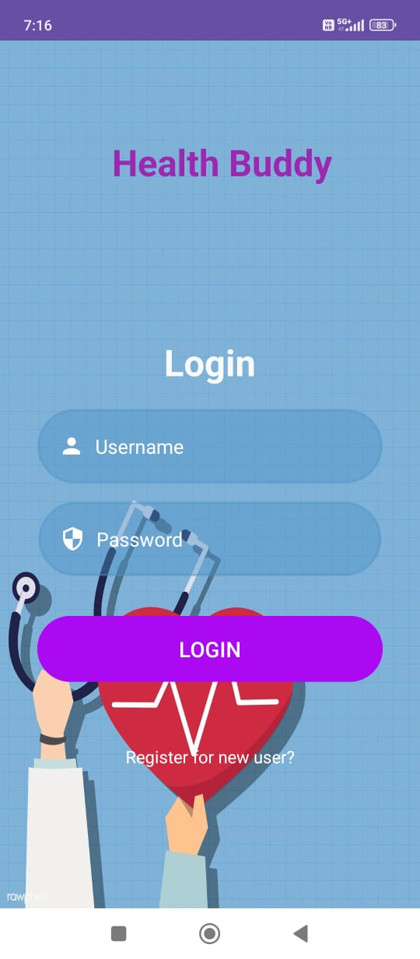

Fig.1.login Page

The login page is where users can authenticate themselves by entering their username and password. It often includes options for password recovery and account creation. The page is designed for ease of access, ensuring that users can quickly log into their accounts to proceed with further actions in the app. Additionally, there may be options for social media logins or multi-factor authentication for added security.
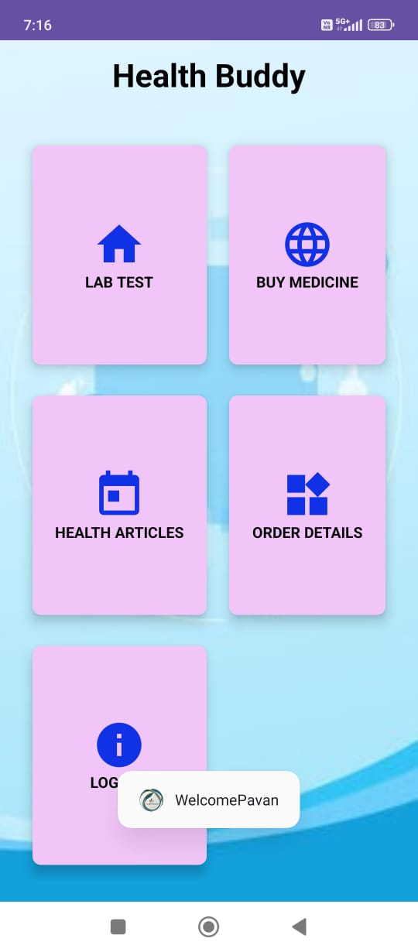

Fig.2.Home Page

The home page serves as the main dashboard of the application. It provides a navigation hub for users to access various features, including lab tests, medicines, health articles, and more. The layout typically includes a clean, user-friendly interface with icons or menus leading to specific sections of the platform. Users can also view promotional offers or updates about new services, helping to keep the interface engaging and informative.

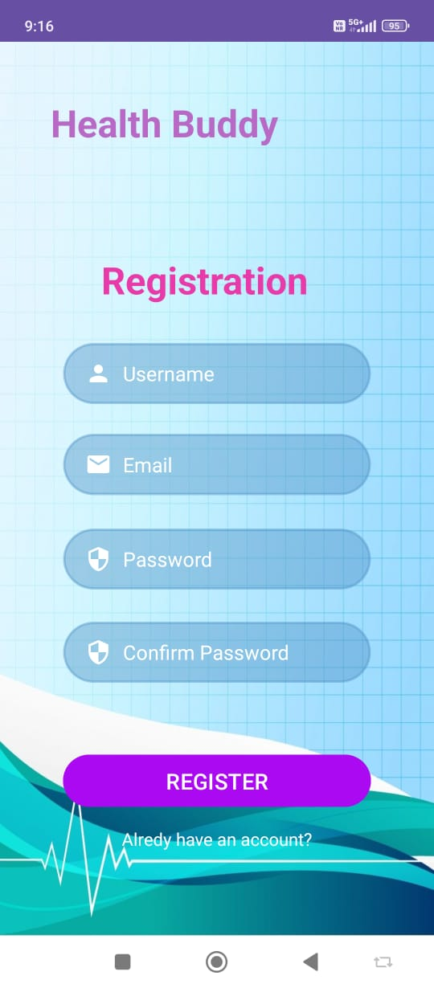

Fig.3.Registration Page

The registration page allows new users to create an account by entering their personal details such as name, email, phone number, and password. This page may also include terms and conditions or privacy policy links for users to review before completing their registration. Upon successful registration, users can log in to the app and begin using its features, often with a confirmation email or SMS for verification.

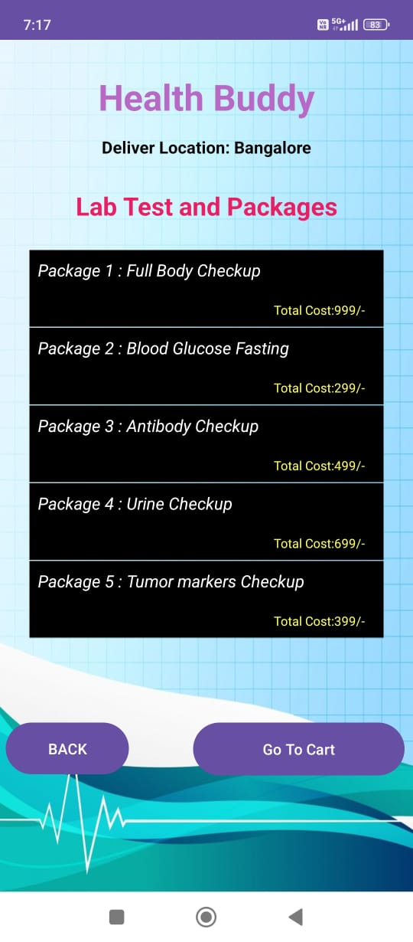

Fig.4.Lab Test Page

The lab test page allows users to browse available lab tests they can order through the app. This page typically includes detailed descriptions of various tests, including their purpose, cost, and how they are conducted. Users can select the test they need, read any relevant preparation instructions, and add it to their cart. The page may also include options for scheduling test appointments or choosing test packages.
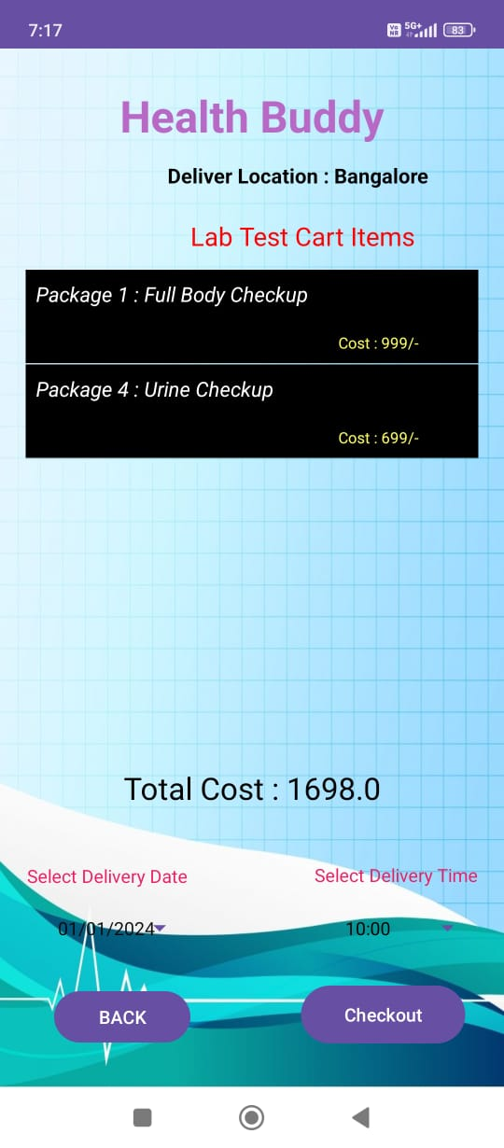

Fig.5.Lab Test Cart Items Page

The lab test cart page provides users with a summary of the lab tests they have added to their cart. Here, they can review the tests, make adjustments to the quantity, or remove items. The page also typically displays the total cost for the selected tests. Users can proceed to checkout, where they’ll finalize their orders and provide payment details. This page might include options for promo codes or discounts.

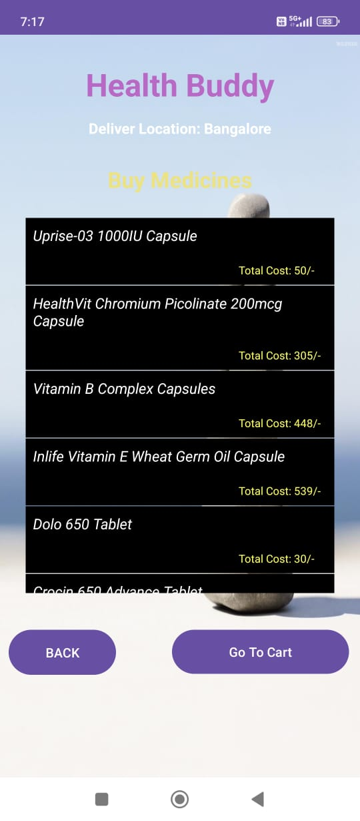

Fig.6.Buy medicines Page

The medicines page features a catalog of medications available for purchase through the app. Users can browse through various categories of medicines, such as over-the-counter drugs, prescribed medications, or wellness supplements. Each item typically includes a description, dosage information, and price. The page may also have filters or a search bar to help users find specific medications or products based on their needs.

Fig.7.Buy medicine Details Page

The Medicines Details Page offers a streamlined catalog of medications and supplements for easy browsing and purchase. Users can explore categories such as over-the-counter drugs, prescription medications, and wellness supplements. Each product listing provides key details like benefits, dosage recommendations, and pricing.

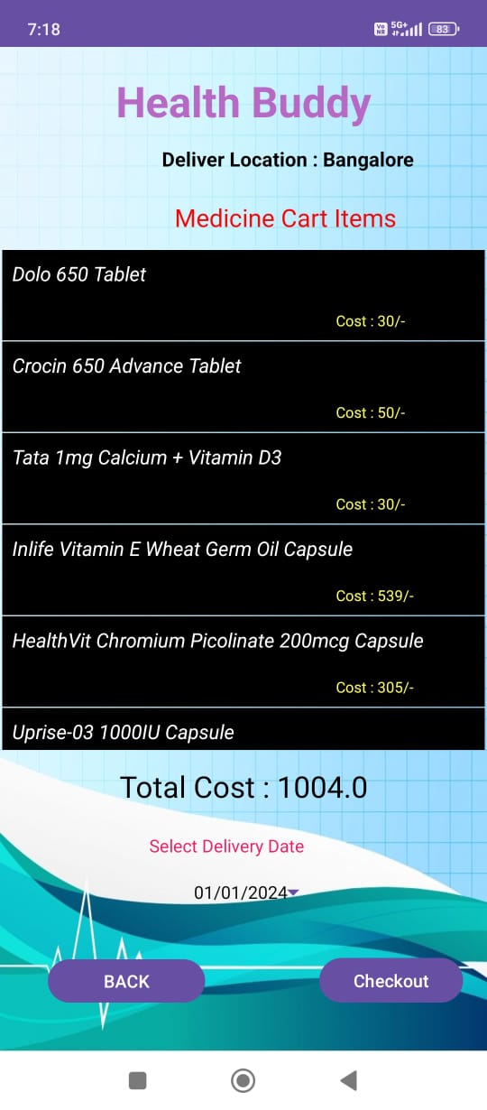

Fig.8.Medicines Cart Page

The medicines cart page shows the items users have added to their shopping cart, including medicines and related products. Users can view each item, its quantity, price, and total cost. Options to edit the cart, such as adding more products or removing items, are available. This page typically includes a summary of the order, taxes, and delivery charges, followed by a checkout button to proceed with the purchase.

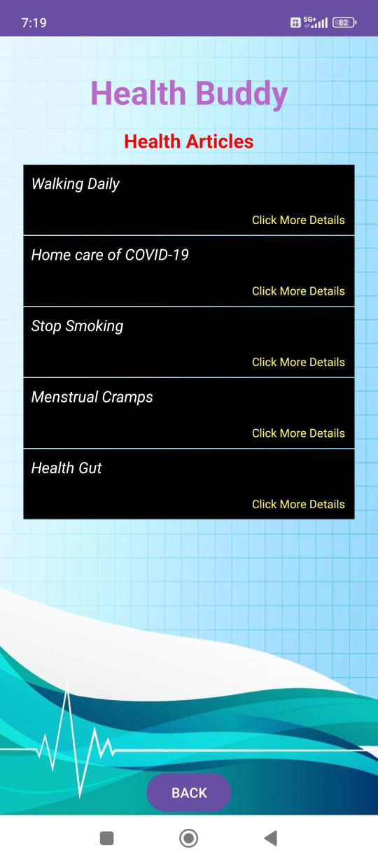

Fig.9.Health Article Page

The health article page displays educational and informative content related to various health topics. Articles may cover general health tips, wellness advice, medical conditions, treatment options, or lifestyle changes. Users can scroll through the content or search for specific topics. The page may also feature images, infographics, and links to related articles, helping users gain a deeper understanding of health-related issues.

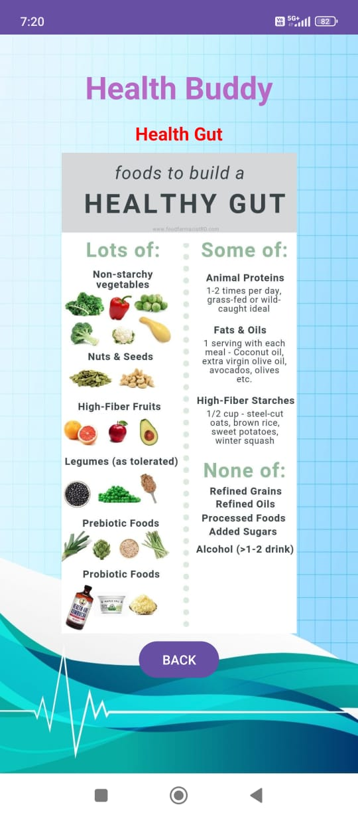

Fig.10.Health Article Details Page

This is another page dedicated to health-related articles. It provides detailed written content, typically including expert opinions, tips, and guidelines for maintaining or improving health. The page may offer interactive elements, such as comment sections or sharing options, encouraging user engagement. Topics can vary from mental health and fitness to chronic illness management, providing a comprehensive resource for users seeking health information.

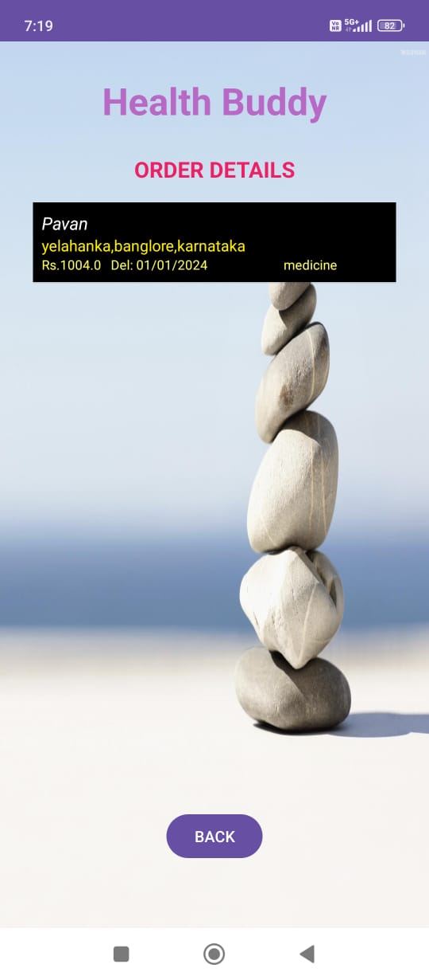

Fig.11.Order Details Page

The order details page provides a comprehensive view of the user’s order, whether it’s for lab tests, medicines, or other services. This page includes itemized details, such as product names, quantities, prices, taxes, and delivery information. It also displays the status of the order, expected delivery time, and payment confirmation. The page typically has options to track the order, modify the delivery address, or cancel the order if needed.

APPENDIX-C
ENCLOSURES

1. Journal publication/Conference Paper Presented Certificates of all students.
2. Include certificate(s) of any Achievement/Award won in any project-related event.
3. Similarity Index / Plagiarism Check report clearly showing the Percentage (%). No need for a page-wise explanation.

4. Details of mapping the project with the Sustainable Development Goals (SDGs).

